**TEST PLAN for LinkedIn**

# **Introduction**

The Test Plan is designed to describe the scope, approach, resources, and schedule of all testing activities of Linkedin mobile application. The plan identify the items to be tested, the features to be tested, the types of testing to be performed, the personnel responsible for testing, the resources and schedule required to complete testing, and the risks associated with the plan

# **Scope**

These are the main features that would be covered on this test plan:

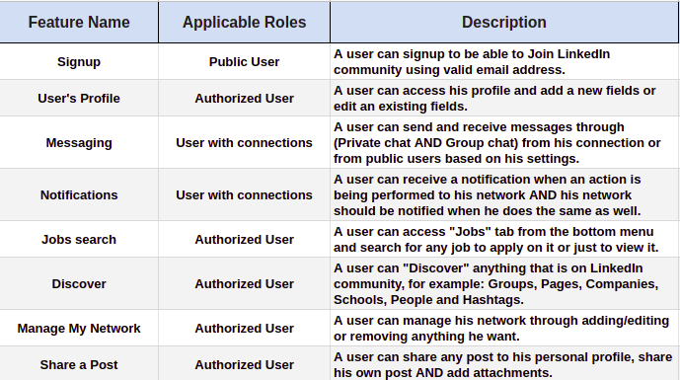

These features won’t be covered on this test plan as they are **out of scope** the requirements:

* Hardware Interfaces
* Database logical
* Website Security and Performance.

# 

# **Quality Objectives**

Our main objective from this test plan is to cover the most important bullet points to find bugs and then be able to solve it later on and to enhance the functionality and user experience of the application.

# **Roles and Responsibilities**

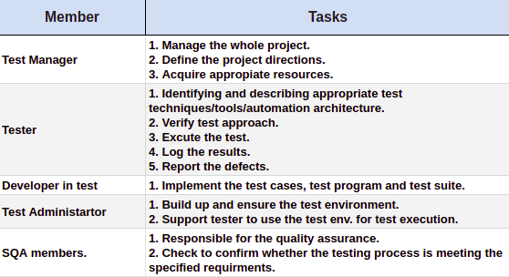

# **Test approach**

As a mobile application project, It should always have new features and enhancements. It’s a large field and the project will have so many competitors so to make sure that the project will lead, we’re going to make changes based on the customers' feedback and we should do it fast to gain their satisfaction.

So, based on the previous Goal. We are going to use an agile approach, with bi-weekly iterations. At the end of each iteration the requirements identified for that iteration will be delivered to the team and will be tested.

## **Test Automation**

Automation testing will cover only the basic and stable features within each iteration, If a feature will be changed in a sprint or two. Automation testing won’t be applied.

# **Overview**

The initial phase will include all “must have” requirements. These and any other requirements that get included must all be tested.

During our work on the product using this test plan, we will discover phase two which may include:

* Load testing.
* Rewriting or moving existing test cases and test scenarios.

Note: You can access test cases for some of these features through this [Sheet](https://docs.google.com/spreadsheets/d/1jNy8x55VyTnjEzmJCr32kPAGPd8F739azRK2NAMpqAY/edit?usp=sharing).

**Suspension Criteria**

If the team members report that there are 40% of test cases failed, suspend testing until the development team fixes all the failed cases.

**Test completeness**

# Specifies the criteria that denote a successful completion of a test phase

# Run rate is mandatory to be 100% unless a clear reason is given.

# Pass rate is 80%, achieving the pass rate is mandatory

# **Risks**

# There is a risk that we might be unable to finish the testing process before a delivery of a milestone, although we should avoid this from the very beginning but if that happened then, at this time we will focus on the impact (severity/ priority) of the un-tested parts to make a decision whether to postpone the deadline of delivering the whole product or reschedule a deadline for the unfinished parts.

### **Test Deliverables**

1. **Before testing phase**

* Test plans document.
* Test cases documents
* Test Design specifications.

1. **During the testing**

* Test Tool Simulators.
* Test Data.
* Test Traceability Matrix and error logs and execution logs.

1. **After the testing cycles is over**

* Test Results/reports
* Defect Report
* Installation/ Test procedures guidelines
* Release notes

Note: There are missing sections on this test plan as there’s no need for them at this challenge so I skipped them.